This Word layout template for Help & Manual defines the entire layout - front page, table of contents, chapter headings, keyword index.
To customize this template, use the original file ("Word-Template-A4.docx") from the H&M installation folder, make a copy of it, then tailor it with MS Word to your requirements. You can use variables in every place of the document. To insert a variable, insert a COMMENT field in Word, then type the variable name as the field content. Like the field above this text.
Move on to the next page in this document to customize the table of contents (a placeholder for the real TOC later) and modify text and paragraph format of the chapter headings in the middle of this template. You might also want to change the numbering style.

Important: before you use the template for publishing in H&M, make sure that general page format and margins are set correctly. H&M will export images and tables to make them fit in the space available.
Index BraillE
hANTVERKSVÄGEN 20,
+46-920-203080
+46-920-203085

Index Braille
2020
Index V5 printer manual

Contents
Index Braille 1
1. Safety information 4
1.1. Approvals 4
2. Index V5 printer overview 6
2.1. Backlit text on all models 6
2.2. Basic-D 6
2.2.1. LED feedback Basic-D 7
2.3. Everest-D 7
2.3.1. LED feedback Everest-D 9
2.4. BrailleBox 9
2.4.1. LED feedback BrailleBox 11
2.4.2. Electrical connectors BrailleBox 11
2.5. FanFold-D 11
2.5.1. LED feedback FanFold 12
2.5.2. Electrical connectors FanFold 13
2.5.3. Wheel montage FanFold 13
3. Installation 13
3.1. Getting started 13
3.1.1. Unpacking of the printer 13
3.1.2. Speech feedback 14
3.1.3. Firmware upgrade 15
3.2. Index Braille Printer Driver 15
3.2.1. Install to USB port 16
3.2.2. Network connection 16
3.3. Printing braille 17
3.3.1. Braille App 18
3.3.2. Index-direct-Braille (idB) 25
3.3.3. External braille editor 26
4. Control panel 26
4.1. Menu summary 27
4.1.1. V5 menu 27
4.1.2. Key functions 27
4.1.3. Multiple layouts to customize 29
4.1.4. Menu option V5 29
4.2. Wizards 33
4.2.1. Standard layout wizard 33
4.2.2. Advanced layout wizard 35
4.2.3. User defined paper wizard 36
4.2.4. User service wizards 37

Safety information
- Securely place the printer on a stable surface.
- Keep the ventilation inlets and outlets of the braille printer free.
- Connect the braille printer to a grounded power outlet only.
- Warning: This is a class A product. In a domestic environment this product may cause radio-interference in which case the user may be required to take adequate measures.
- Warning: The user is recommended to use ear protection or an Acoustic Hood to reduce the sound pressure. Long-time exposure without protection can lead to hearing loss.

Approvals
FCC Compliance

This device contains FCC ID: PVH0953

This equipment has been tested and found to comply with the limits for a Class B digital device, pursuant to Part 15 of the FCC Rules. These limits are designed to provide reasonable protection against harmful interference in a residential installation. This equipment generates, uses and can radiate radio frequency energy and, if not installed and used in accordance with the instructions, may cause harmful interference to radio communications. However, there is no guarantee that interference will not occur in a particular installation. If this equipment does cause harmful interference to radio or television reception, which can be determined by turning the equipment off and on, the user is encouraged to try to correct the interference by one or more of the following measures:
- Reorient or relocate the receiving antenna
- Increase the separation between equipment and receiver
- Connect the equipment into an outlet on a circuit different from that to which the receiver is connected

Consult the dealer or an experienced radio/TV technician for help.

IC compliance

This device contains IC: 5325-0953

This device complies with Industry Canada license-exempt RSS standard(s).
Operation is subject to the following two conditions:
this device may not cause interference, and this device must accept any interference, including interference that may cause undesired operation of the device. Under Industry Canada regulations, this radio transmitter may only operate using an antenna of a type and maximum (or lesser) gain approved for the transmitter by Industry Canada. To reduce potential radio interference to other users, the antenna type and its gain should be so chosen that the equivalent isotropically radiated power (e.i.r.p.) is not more than that necessary for successful communication. The device for operation in the band 5150-5250 MHz is only for indoor use to reduce the potential for harmful interference to co-channel mobile satellite systems; the maximum antenna gain permitted for devices in the bands 5250-5350 MHz and 5470-5725 MHz shall comply with the e.i.r.p. limit; and the maximum antenna gain permitted for devices in the band 5725-5825 MHz shall comply with the e.i.r.p. limits

Conformité aux normes d’IC
Cet appareil est conforme à la(aux) norme(s) RSS sans licence d’Industry Canada.
Son utilisation est soumise aux deux conditions suivantes :
Cet appareil ne doit pas causer d’interférences et il doit accepter toutes interférences reçues, y compris celles susceptibles d’avoir des effets indésirables sur son fonctionnement. Conformément aux réglementations d’Industry Canada, cet émetteur radio ne peut fonctionner qu’à l’aide d’une antenne dont le type et le gain maximal (ou minimal) ont été approuvés pour cet émetteur par Industry Canada. Pour réduire le risque d’interférences avec d’autres utilisateurs, il faut choisir le type d’antenne et son gain de telle sorte que la puissance isotrope rayonnée équivalente (p.i.r.e) ne soit pas supérieure à celle requise pour obtenir une communication satisfaisante. Le dispositif de fonctionnement dans la bande 5150-5250 MHz est réservé à une utilisation en intérieur pour réduire le risque d'interférences nuisibles à la co-canal systèmes mobiles par satellite, le gain d'antenne maximal autorisé pour les appareils dans les bandes 5250-5350 MHz et 5470-5725 MHz doit se conformer à la pire limite, et le gain d'antenne maximal autorisé pour les appareils dans la bande 5725-5825 MHz doivent être conformes avec le pire limites spécifiées à point-à-ponctuelles et non point-à-point de fonctionnement selon qu'il convient. Opération dans la bande 5600-5650 MHz n'est pas autorisée au Canada. Haute puissance radars sont désignés comme utilisateurs principaux (c.-àutilisateurs prioritaires) des bandes 5250-5350 MHz et 5650-5850 MHz et que ces radars pourraient causer des interférences et / ou des dommages à dispositifs LAN-EL. Cet équipement respecte les limites d’exposition aux rayonnements IC RSS-102 définies pour un environnement non contrôlé. Il doit être installé et utilisé en maintenant une distance minimum de 20 cm entre le radiateur et votre corps.

Bloutooth Qualification
This device contains Bluetooth module qualified as "Controller system" - QD ID 58171

Japan radio equipment compliance
The ODIN-W1 module complies with the Japanese Technical Regulation Conformity Certification of Specified Radio Equipment (ordinance of MPT N°. 37, 1981), Article 2, Paragraph 1:
- Item 19 "2.4 GHz band wide band low power data communication system"
- Item 19-3 “Low power data communications system in the 5.2/5.3 GHz band”
- Item 19-3-2 “Low power data communications system in the 5.6 GHz band”
The ODIN-W1 MIC certification number is 204-510008.
The ODIN-W1 module is restricted on the Japanese market to be used indoors only, if operating in the 5.2/5.3 GHz band.

LVD Low Voltage Directive
This device shall be connected to a close and easily accessible grounded outlet.

Index V5 printer overview
Speech feedback refers to the echo in the printer.

Backlit text on all models
Bluetooth, Wi-Fi, Network: Flickers when available, and lights up when connected.
idB: Flickers during translation, and lights up during printing with idB.
UPDATE: Require a network connection. Activated when the printer is connected to a network with internet access. It lights up when an update is available and flickers during a firmware upgrade.
PAPER JAM: Lights up when there is a paper jam.
ERROR: Lights up when there is an error. Press HELP for more information.

Basic-D
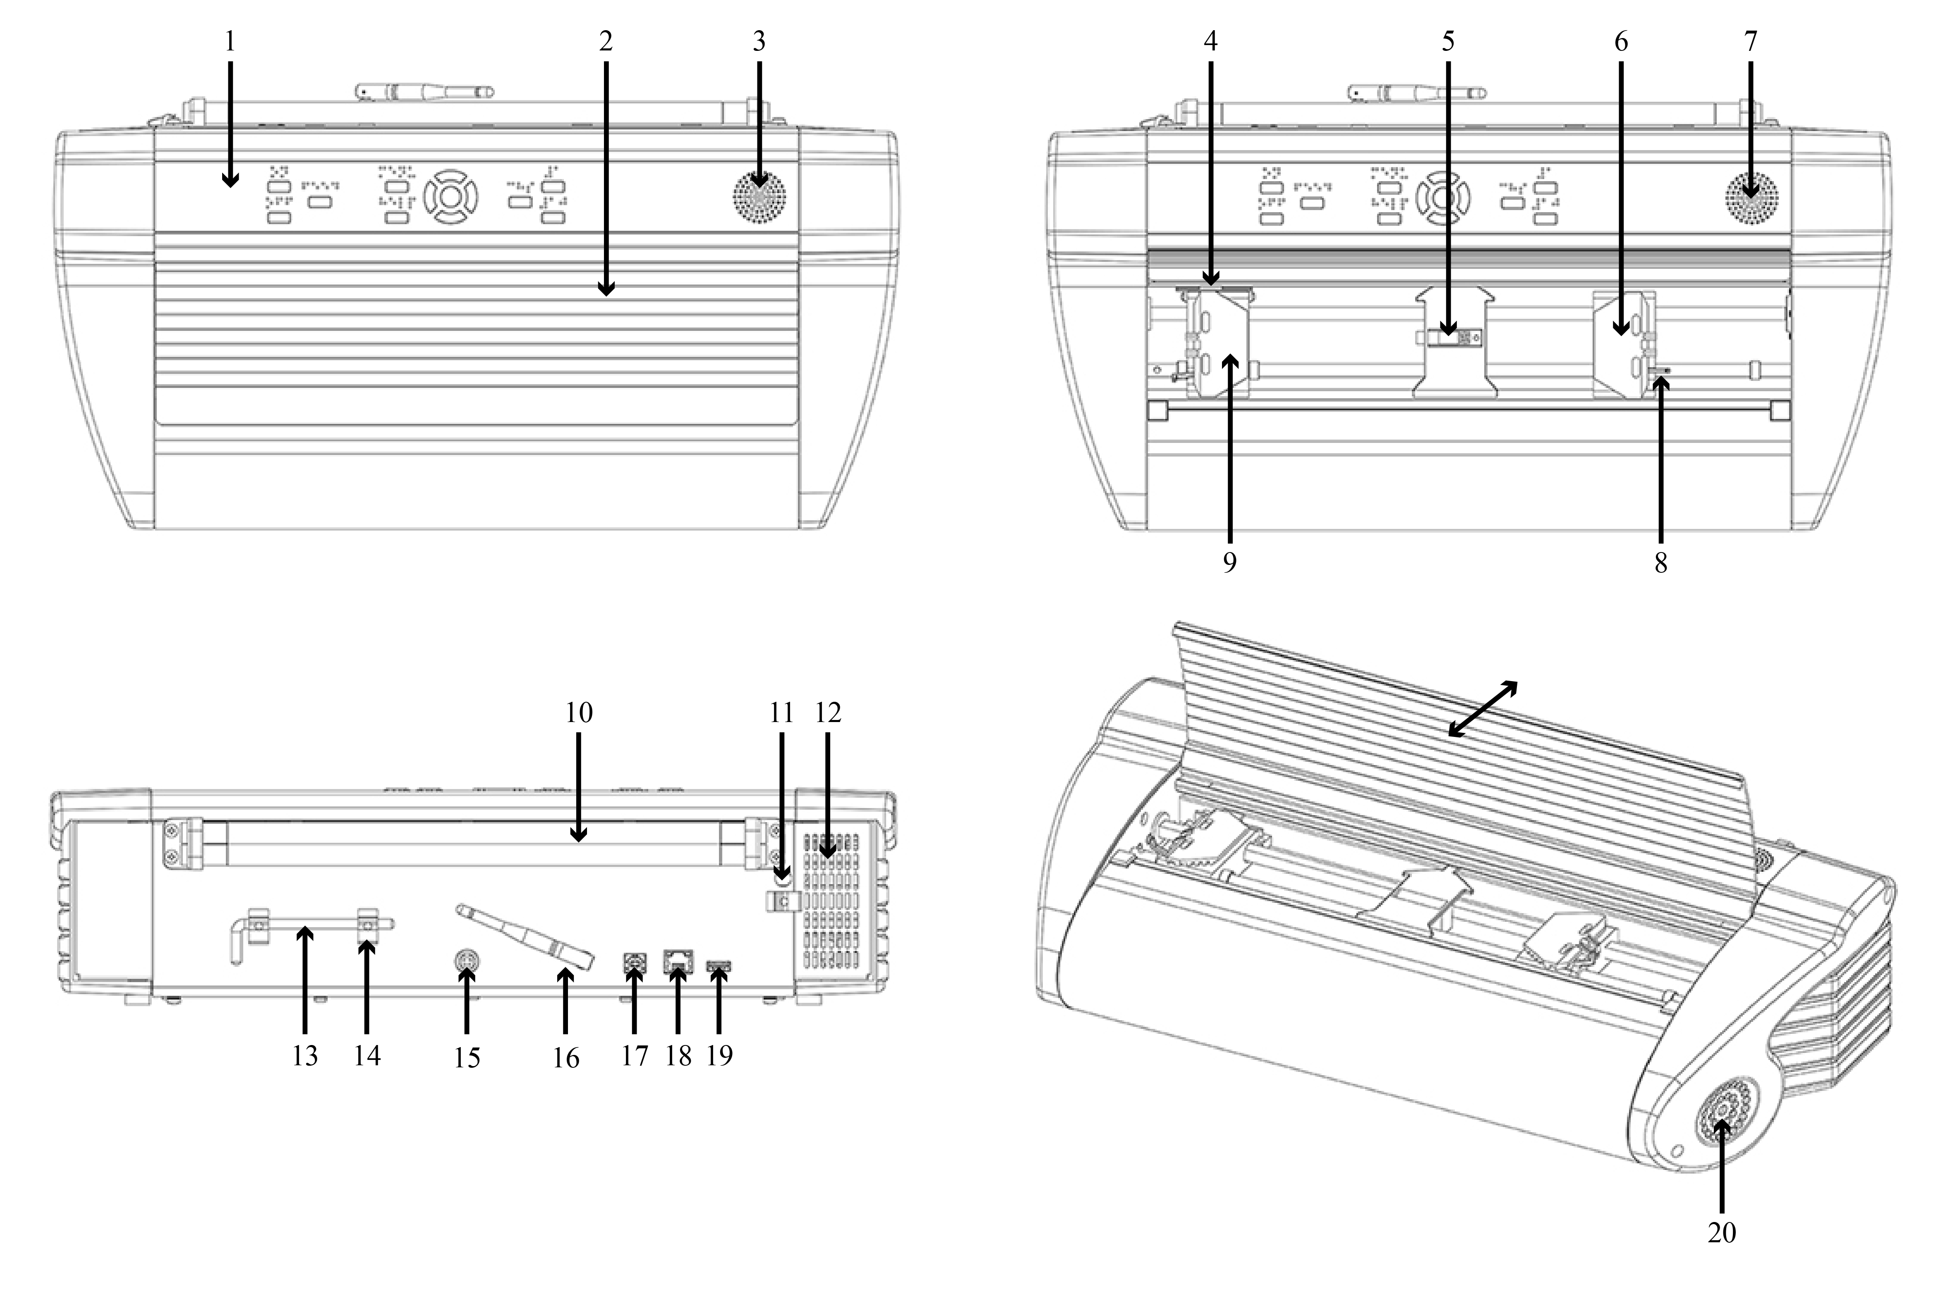
1. Control panel  2. Lid  3&7. Speaker  4. Optical paper movement sensor  5. Optical paper edge sensor  6. Right tractor  8. Tractor release lever  9. Left tractor | 10. Paper rollers  11. Hole for transport lock  12. Ventilation inlet  13. Transport lock  14. Transport lock holder  15. Power input 48V DC  16. Wi-Fi and Bluetooth antenna  17. USB 2.0 device port  18. Network port (100 MB)  19. USB host port  20. Ventilation outlet

LED feedback Basic-D
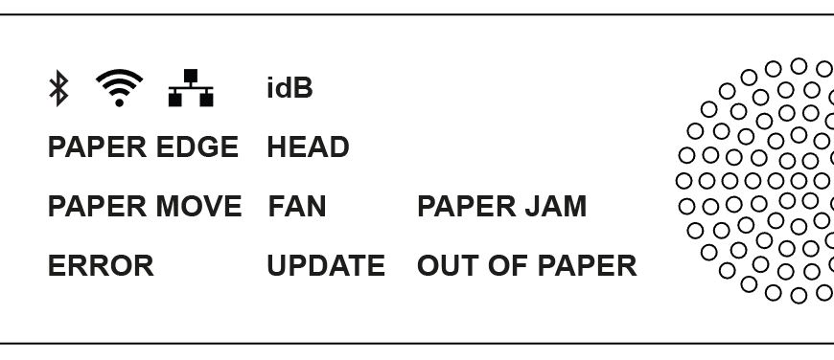

PAPER MOVE: Flickers when paper is moving.
PAPER EDGE: Lights up when paper is in front of the paper edge sensor.
HEAD: Lights up when the print head is in the home position.
FAN: Lights up when the fan is on.
OUT OF PAPER: Lights up when there is no paper in the paper tractor.

Everest-D
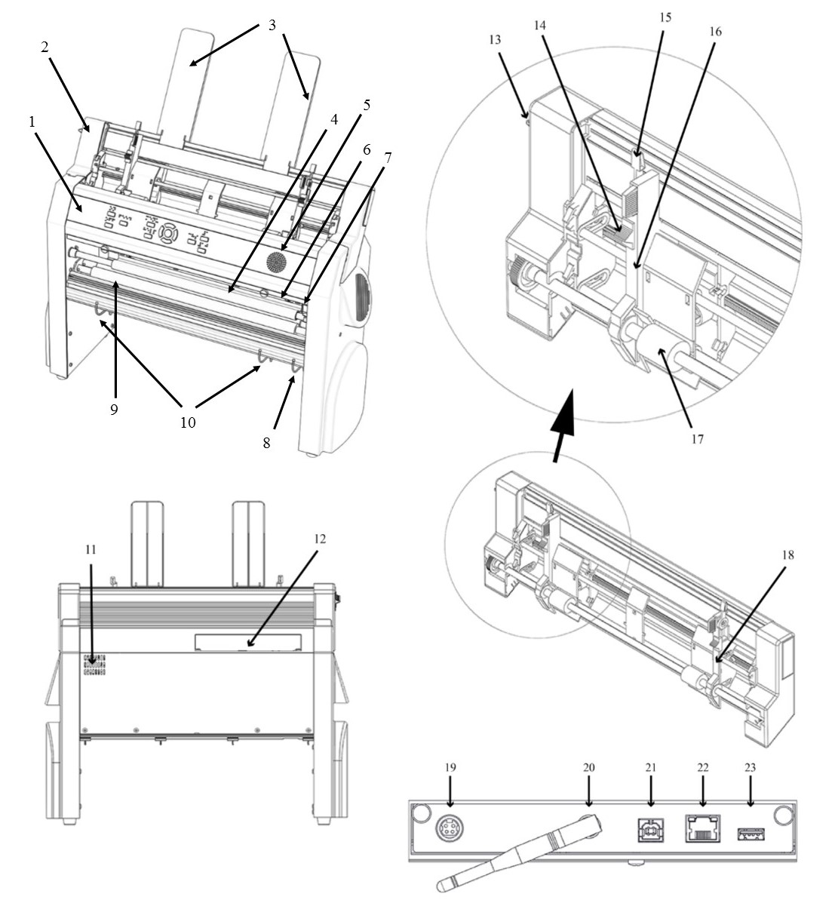
1. Control panel  2. Sheet feeder  3. Paper guides  4. Embossing head  5. Speaker  6. Optical paper edge sensor  7. Optical embossing head reference position sensor  8. Outer guides for adjusting paper out profile angle  9. Paper movement rollers  10. Inner guides to stabilize paper out ejection | 11. Ventilation outlet  12. Electrical connectors (19-23)  13. Switch to close/open the sheet feeder  14. Card/sheet selectors (right/left)  15. Locking levers for margin guides (right/left)  16. Left margin guide  17. Pick-up rollers  18. Right margin guide  19. Power input 48V DC  20. Wi-Fi and Bluetooth antenna  21. USB 2.0 device port  22. Network port (100 MB)  23. USB host port

LED feedback Everest-D
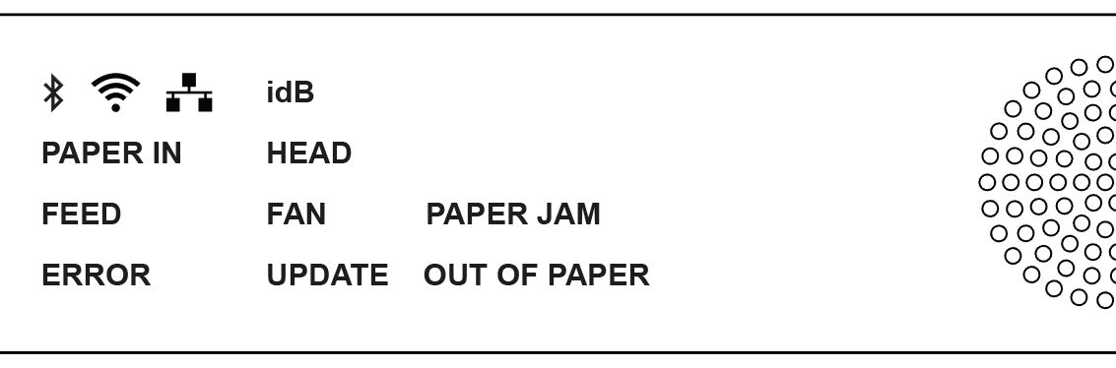
PAPER IN: Lights up when paper is in front of the paper edge sensor.
FEED: Lights up when paper motor is on.
HEAD: Lights up when the print head is in the home position.
FAN: Lights up when the fan is on.
OUT OF PAPER: Lights up when the paper tray is empty.

BrailleBox
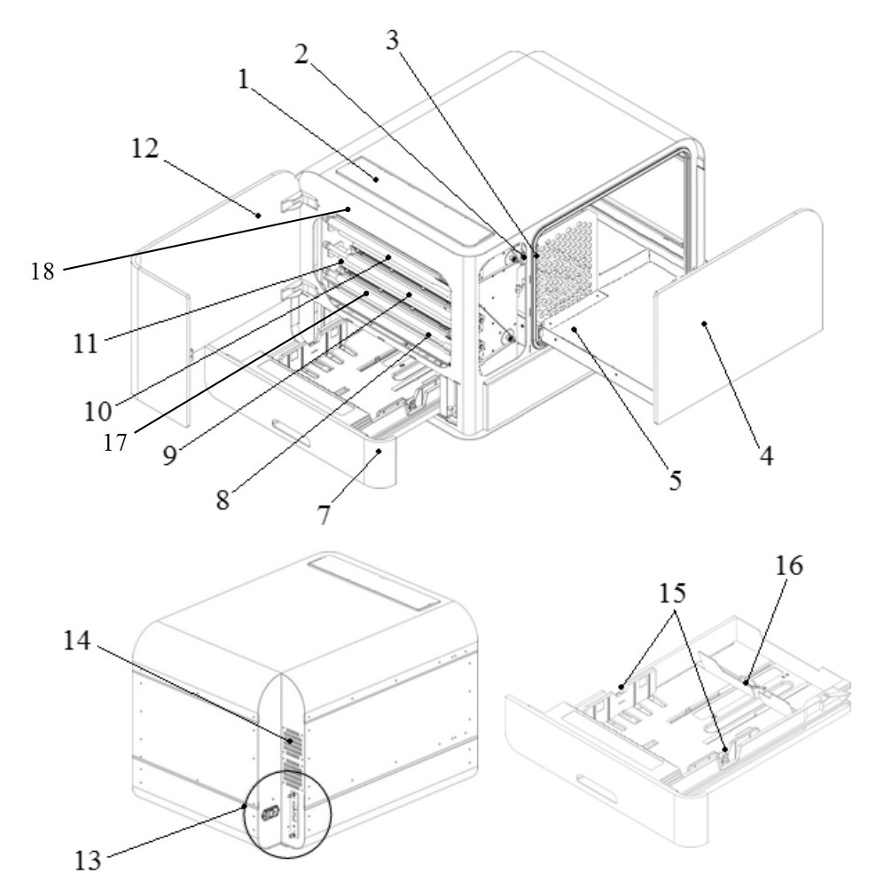
1. Control panel  2. Optical sensor for service door  3. Optical sensor for braille tray  4. Braille tray  5. Braille stack guide  7. Paper tray  8. Bottom embossing 1 | 9. Middle embossing 2  10. Top embossing 3  11. Paper rollers  12. Service door  13. Electrical connectors  14. Ventilation  15. Paper guides  16. Rear paper stop lever  17. Paper-in sensor  18. Paper-out sensor

LED feedback BrailleBox
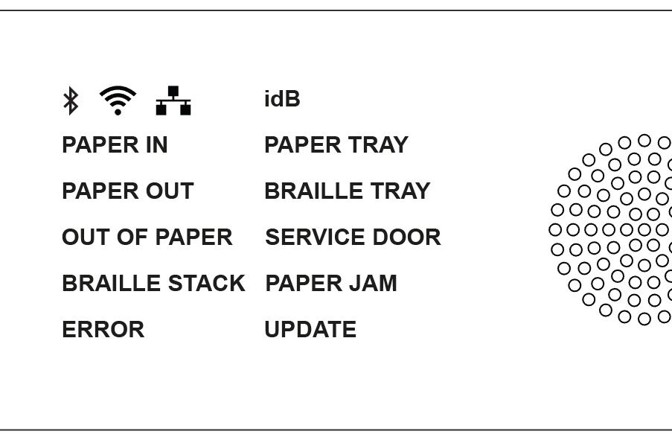

PAPER IN: Lights up when paper has begun feeding and reaching the paper-in sensor.
PAPER OUT: Lights up when paper reaches the paper-out sensor.
OUT OF PAPER: Lights up when the paper tray is empty.
BRAILLE STACK: Lights up when the braille stack is too high.
PAPER TRAY: Lights up when the paper tray is open.
BRAILLE TRAY: Lights up when the braille tray is open.
SERVICE DOOR: Lights up when the front service door is open.

Electrical connectors BrailleBox
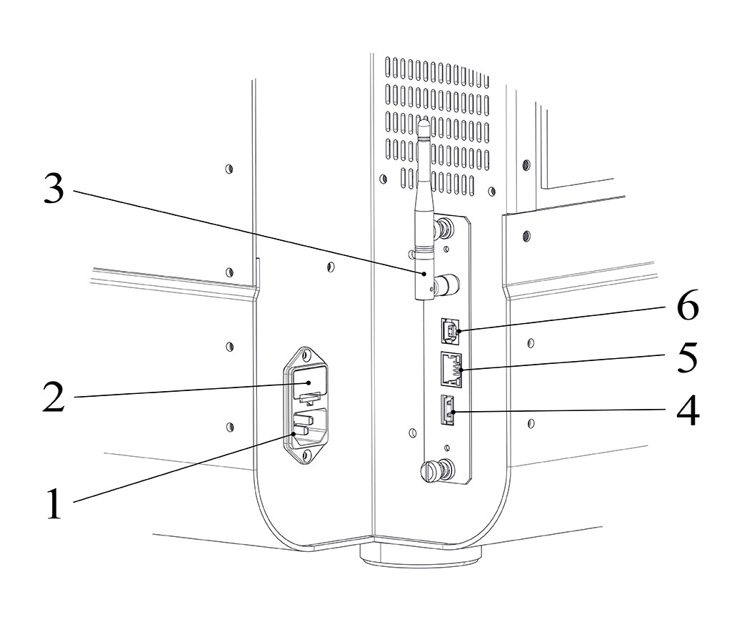 | 1. Power input 100-240V, 50-60 HZ, grounded outlet  2. Fuse 6,3 A/250V slow blow  3. Wi-Fi and Bluetooth antenna  4. USB host port  5. Network port (100 MB)  6. USB 2.0 device port

FanFold-D
- 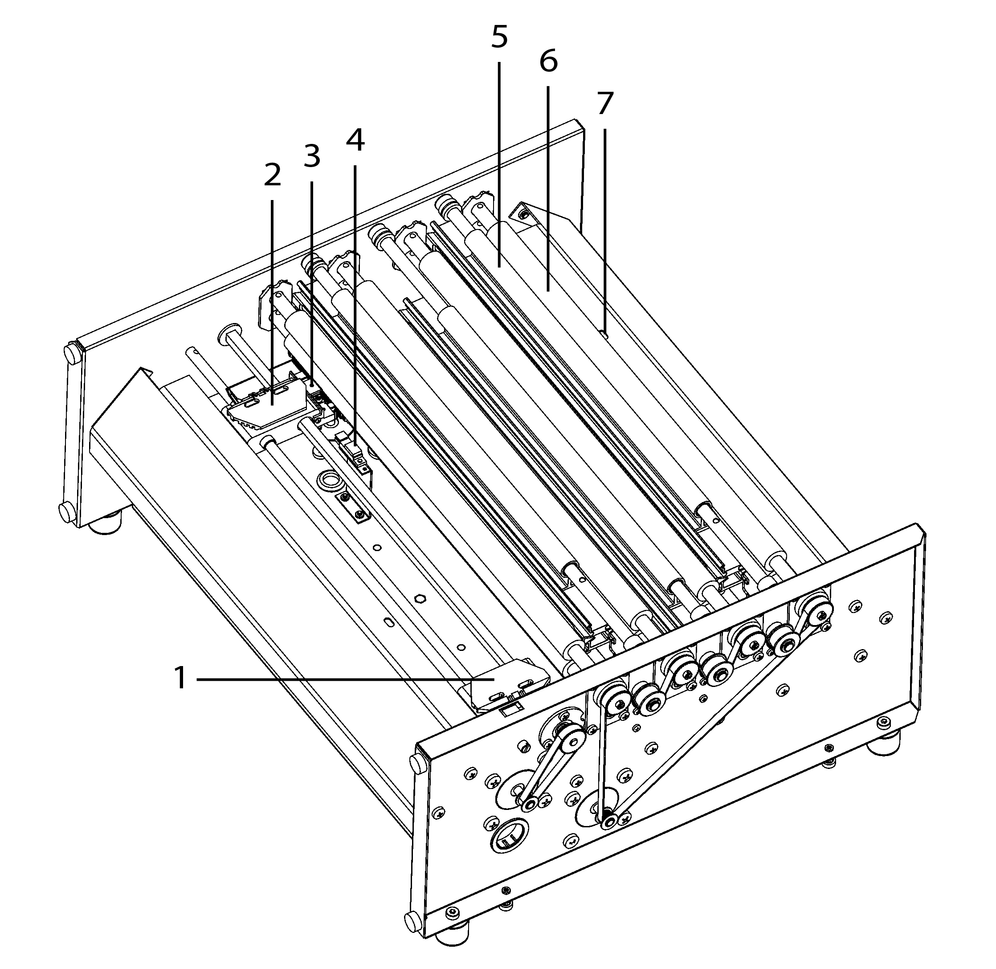 | - Embossing head 1  - Embossing head 2  - Embossing head 3  - Right paper tractor  - Left paper tractor  - Paper move sensor  - Paper edge sensor  - Soft paper movement rollers (4 pairs)  - Paper out sensor

LED feedback FanFold
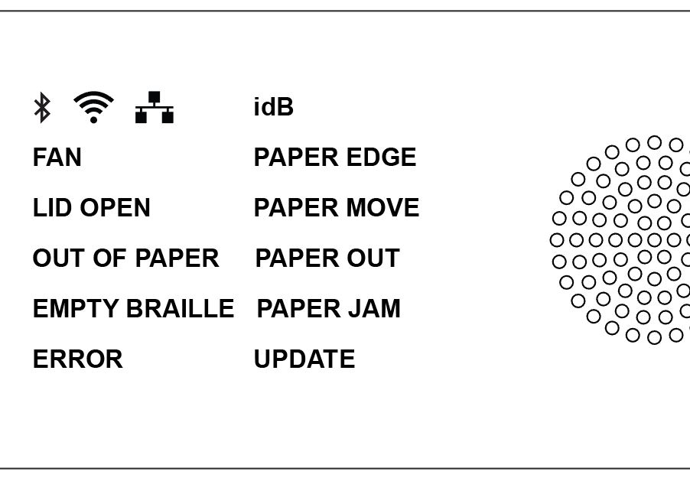
PAPER EDGE: Lights up when paper has begun feeding and reaching the paper-in sensor.
PAPER MOVE: Flickers when paper is moving.
PAPER OUT: Lights up paper cover the paper out sensor.
FAN: Lights up when the fan is on.
LID OPEN: Lights up when the top glass lid is open.
EMPTY BRAILLE: Lights up when when it is time to empty the braille stack.

Electrical connectors FanFold
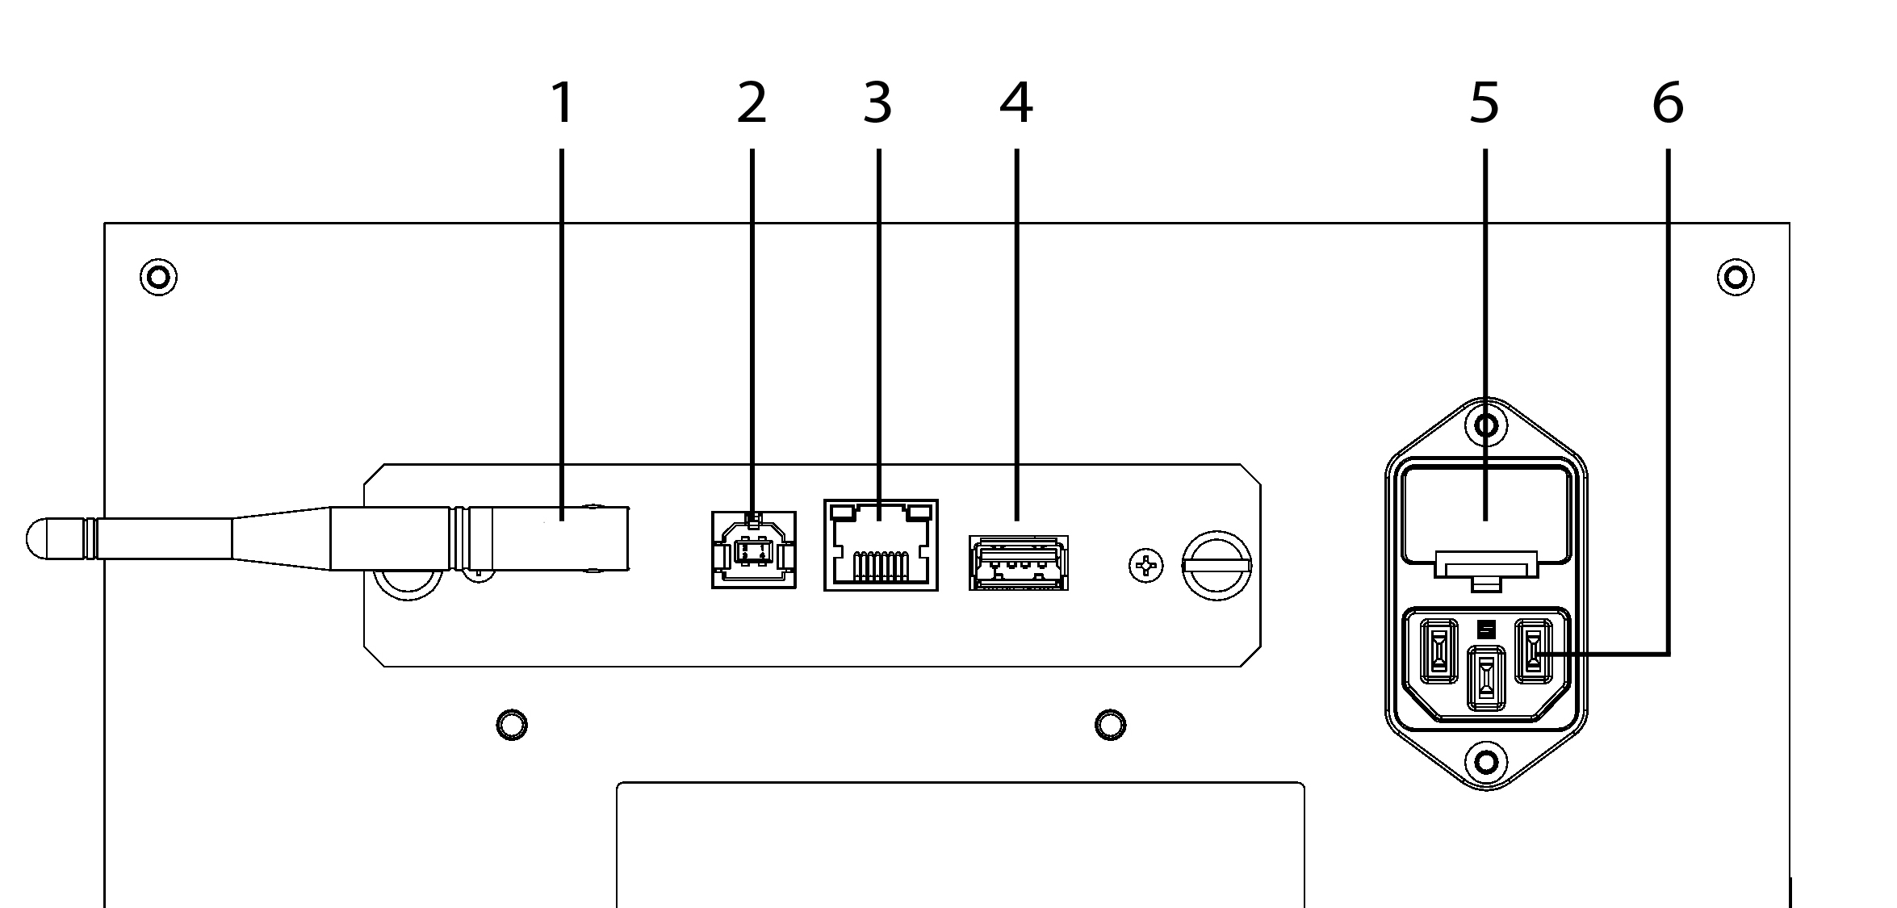 | 1. Wi-Fi and Bluetooth antenna  2. USB 2.0 device port  3. Network port (100 MB)  4. USB host port  5. Fuse 6,3 A/250V slow blow  6. Power input 100-240V, 50-60 HZ, grounded outlet

Wheel montage FanFold
- Remove the upper packing material.
- Rotate the FanFold so the first corner is outside of the bottom packing material. Montage the first wheel with the bolts from bottom and upwards. The bolts and wrench are included inside the printer.
- Repeat step 2 for wheel two and three.
- Move the bottom packing material outside of the FanFold-D except one corner supporting close to the position of last wheel. Montage the last wheel and remove the bottom packing material.

Link to video FanFold-D Getting Started

Installation

Getting started

Unpacking of the printer
Unpack the printer gently and check all items. Keep the packing material and transport locks. The four (4) year warranty on parts remains valid only if the printer is transported in original packaging, and the transport locks are properly in place.

The following items are included in shipment:
  - Braille printer
  - User manual
  - Power cord
  - Index USB memory stick
  - USB cord
  - USB extension cord for USB memory stick
  - External power supply for Basic-D and Everest-D.
  - Transport locks

First time starting up
  - Remove the accessory kit box from the packing.
  - Montage the wheels on FanFold-D
  - Connect the power cord and press ON to power on the printer without connecting the USB cord.
  - The Wizard to remove transport locking will start automatically.
  - Follow the wizard steps. When completed, the printer will restart and is ready to be used.

BrailleBox picture
- Rubber seal  - Accessories kit box  - Braille tray glass  - Print head transport locks | 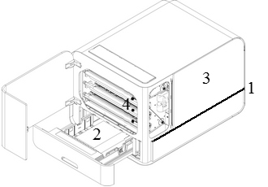

Speech feedback
The speech feedback is set to English (factory delivery).

Following languages are available in Acapela synthetic speech:
Arabic, Czech, Danish, Dutch, English (Indian), English (UK), English (US), Finnish, French, German, Italian, Japanese, Korean, Mandarin, Norwegian, Portuguese (Brazil), Portuguese (Portugal), Russian, Spanish, Spanish (Latino), Polish, Swedish and Turkish.
Above languages is available as the local user interface when corresponding language specific translation file is generated and embedded in the embosser firmware.

Firmware upgrade
An Index printer can be upgraded to latest firmware free of charge. It is highly recommended to upgrade the firmware when installing a new Index V5 printer. The upgrade includes bug fixes and new or improved functionality. Please find detailed information at Latest V5 Firmware

Upgrade via Internet connection
When the V5 printer is connected to internet, it checks for an update automatically. The UPDATE text lights up indicates that new update is available.
Start upgrade by selecting:
MENU / User service / Firmware upgrade / Firmware upgrade from internet / OK to start.

Upgrade via USB memory stick
  - Download the latest V5 firmware on Index Braille Support / Download V5 firmware. File name example: Embosser-update-YYYY-MM-DD.zip.
  - Save the V5 firmware file to a USB memory stick.
  - Insert the USB memory stick into the V5 printer.
  - Start the upgrade by pressing:
MENU / User service / Firmware upgrade / Firmware upgrade from USB memory stick / OK to start.

The UPDATE text lights up during the upgrade process. The speech feedback is activated. Do not power off the printer during an upgrade. The upgrade process may take 5-15 minutes and is completed when the printer restarts automatically.

Index Braille Printer Driver
Index software and printer drivers for Index Braille printers may be installed from the USB memory stick, included in the shipment or by downloading them from link to Index printer drivers.

Install to USB port
All Index printers require the Index Braille Printer Driver to function properly on a USB port.
Install the Index Braille printer driver in your computer before connecting the printer to the USB device port.

To find the current version of the Index Braille printer driver for your printer, access the control panel in your computer by selecting:
  - Control Panel / Uninstall a program / Index Braille Driver.
  - The current version number is shown on the right hand column, listed under versions.

Windows
To install Index printer driver 8.3. or higher, suitable for Windows XP, Vista, Win 7, Win 8, Win 10, follow these steps:
- Close all applications on your PC.
- Download Index Printer Driver 8.3 or higher.
- Right click the driver installation file and select "Run as administrator" and follow the installation wizard.
- Connect the supplied USB cord.
- Turn on the printer.
- For Windows Vista and later versions, the Plug & Play Found new hardware wizard will complete the USB installation.

Link to install Index Printer driver on Mac OS X
Link to install Index Printer driver on Linux (Debian/Ubuntu)

Network connection
The lighted network icon on the control panel lights up when a network connection is established.
The MAC address of your V5 Index printer is available on the "network information page" printout and in the BrailleApp/ Communication/ Wired Network or WiFi/ Hardware Address.

Wired IP network setup
First step to connect to a wired network
Plug in the network cord to a Local Area Network (LAN) with DHCP support.
  - The wired network icon flickers when establishing a network connection.
  - The network icon lights up when the network connection is established.
  - Speech feedback "Wired network connected, IP address is XXX.YYY.ZZ.WW

Wizard for static IP address
MENU / Communication / Wizard for wired network / OK.
Link to Connect Index V5 to wired network

Wi-Fi network setup
There are alternative ways to setup Wi-Fi network IP connection:
  - Set up IP with the Web-App (Recommended)
  - Set up IP with Wi-Fi setup file
  - Set up with WPS (Wi-Fi Protected Setup - WPS button on the router)
  - Set up Wi-Fi network from control panel

Once the Wi-Fi or wired network has been connected, the printer will remember the network name (SSID) and password.

Reservation of IP address on a DHCP Router
The best way to reserve a permanent IP address to a specific Index printer is via reservation of the MAC address of the printer to a specific IP address on the router. This is typically a task for the Network Administrator. For detailed information, search on the internet for "Reservation of IP address on DHCP + (Your router name)".

Printing braille
Index-direct-Braille (idB) is a direct printing application in Index V5 to print standard documents (docx, doc, pdf, epub) in braille without using a traditional braille editor.
Link to more information about idB

IdB Characteristics:
  - Translates and formats the braille printout following the settings in the active layout.
  - Text-to-braille translation (Liblouis tables) in literary or contracted braille (more than 140 languages)
  - Formats the text into braille page size (lines/page, character/line, margins, braille page number, volume page number)
  - Latest idB functions are automatically installed after upgrading the V5 embosser firmware. In January 2020 the text-to-braille translation files in Liblouis 3.12.0 are implemented.
Link to Liblouis open source community tables in Liblouis 3.12.0
  - idB supports multiple users in the network.
  - idB is free of charge.

For braille mathematics, music, tactile graphics and complex documents a separate braille editor is required.

Braille App
The BrailleApp is an embedded application to supporting braille printing (translate, view, edit, save into braille G1/G2), setup, monitor and remote support of the V5 braille printer. By using the BrailleApp it is not necessary to purchase a commercial braille editor.

Requirements for using the BrailleApp
  - Index V5 printer (Basic-D, Everest-D, FanFold-D or BrailleBox)
  - The printer must be connected to a network (IP-port, wired or WiFi)
  - A device, (pc, pad, phone etc), connected to the same network
  - A modern browser
BrailleApp characteristics
  - The BrailleApp uses Liblouis text-to-braille translation open source platform, including more than 150 languages in computer, literary and contracted braille.
  - The BrailleApp supports all major operation systems as Windows, iOS, Linux, Unix and Android.
  - The BrailleApp is distributed via the embosser firmware. New versions will be available after upgrading the embosser firmware.
  - The BrailleApp is free of charge, no license is required and several users can use the same printer.
  - The BrailleApp includes remote support which enable on line service via internet.
  - The user is guided by the app menu and information screens. No manual is needed.
  - Screen reader support, tested on JAWS, NDVA and Voice over.

Getting started
First connect your V5 printer to a wired network port (IP-port). When the network icon is lighted the network connection is established.
  - Get the IP address of your V5 printer
    - HELP+10 in voice feedback
    - HELP+1 print network information page
  - Open your favorite browser and type the printers IP address in the search window of the browser (For example http://192.168.4.14). This process is the same in Windows, iOS, Linux, Unix and Android.
  - The BrailleApp home page is now presented.
Link to web mocup of the BrailleApp

Braille layout
To view layouts and to select active layout go to BRAILLE LAYOUT.
The Braille Layout shows number of layouts, the parameter for each layout.
Functions in this menu:
  - View layout, the active layout is presented with green background
  - Set active layout, the selected layout is the one used by the printer
  - Edit layout. This is a wizard where the same parameters as in advanced setup from the control panel is presented and each step can be edit.
  - Add layout, adds a new layout with the lowest available number. The new layout gets the same values on parameters as active layout and is the new active layout.
  - Delete layout, the selected layout will be deleted. It is not possible to delete the active layout.

Other menus in BRAILLE LAYOUT are:
  - Backup and restore layouts
  - User defined paper
  - User defined tables

Supported file formats
The BrailleApp supports printing braille from standard files in .doc .docx .pdf .epub. These files are translated, formatted and page numbered, following the settings in Active layout.
The BrailleApp also supports the .dxb file format used by Duxbury. In this case the BrailleApp will open the .dxb file as a translated braille document. If the page layout (character per line, lines per page) is the same as in Duxbury, the braille view text is presented identical in the BrailleApp as in Duxbury. If the braille page layout differs, the user will get the choice to re-format the braille text layout in the BrailleApp.
Files that can open and send to the printer, but not previewed are:
  - .brf (Braille file - prints with MIT Legacy braille table)
  - .ibe - (Index Braille Files - command file for Index embossers)
  - .bra (a file format used by ONCE braille editor)
  - .elpt (Epics tactile graphic software)
  - .ebf (Duxbury translated file - print with MIT Legacy braille table)

The BrailleApp can save the translated Braille document in .ipf (Index Print Format). This file format can be opened again in preview window, re-edit and saved in the BrailleApp.

Browse, preview, edit and print Braille
When printing Braille with the BrailleApp the text will be translated and formatted following active layout. On the top of the Print menu, the active layout number or complete list of parameters are presented.

When printing a source file (.doc .docx .pdf .epub) the sequence is the same independent if the BrailleApp is used on a computer, phone, pad etc. The source file can be available from the computer, in the cloud or on a USB memory stick inserted to the V5 printer.

When printing with the BrailleApp the sequence follows the same pattern, regardless of the used device (computer, pone, pad etc.) or if the file is available in the computer or on the USB memory stick connected to the printer.

  - Check that the settings in active layout is correct
  - Browse to the file and select it.
  - Press "Preview" to translate the text and preview the braille text.
    - Presentation in Braille.
Edit braille with six-key-entry (f=1, d=2,s=3, j=4, k=5, l=6), with eight-dot-entry the a=7 and :=8 are added.
    - Presentation in MIT Ascii
The text is presented in American character set and can be edit with a normal keyboard.
Link to more information about North American ASCII Braille Table.
    - Presentation in Text
The braille text by the back translation in the selected Liblouis table. It is not possible to edit in text presentation.
Edit the braille text
    - Open the edit function by pressing on the "pen" icon in Braille (6 key entry) and MIT Ascii presentation (qwerty keyboard).
    - If the Liblouis table is 6-dot braille editing is made in 6-key entry.
    - If the Liblouis table is 8-dot braille editing is made in 8-key entry.
    - Supported editing keys
      - 6 or 8-key entry in Braille mode
      - North American ASCII Braille table characters
      - Delete
      - Backspace
      - Arrow up/down/right/left
      - Add page break with the "new page" icon (pen + page)
Save the translated braille file
  - Save the translated braille file in .ipf (Index Print Format) with the "save" icon.

Print Braille
First go to Braille presentation.
    - Select number of copies
    - Select range
    - Press "Print"

Formatting roles
Rules when printing a docx file and Maintaing formatting (docx) is enabled
  - Text within a paragraph is reformatted to fit the braille page
  - Line breaks are maintained
  - Spaces in beginning of a paragraph are maintained
  - Page break is maintained
  - Tab is replaced with spaces. Number of spaces for each tab is defined in the settings of Maintain formatting (docx)

Rules for doc, pdf and epub and for docx when Maintaining of formatting is disabled
  - Multiple spaces are replaced with one
  - New paragraph is replaced with new line plus two spaces (indent)
  - Page break is removed
  - Tab is replaced by one space

View, edit and select braille layout
In the BRAILLE LAYOUT tab, the layouts of the V5 printer are presented and the active layout market with "Active" and green.
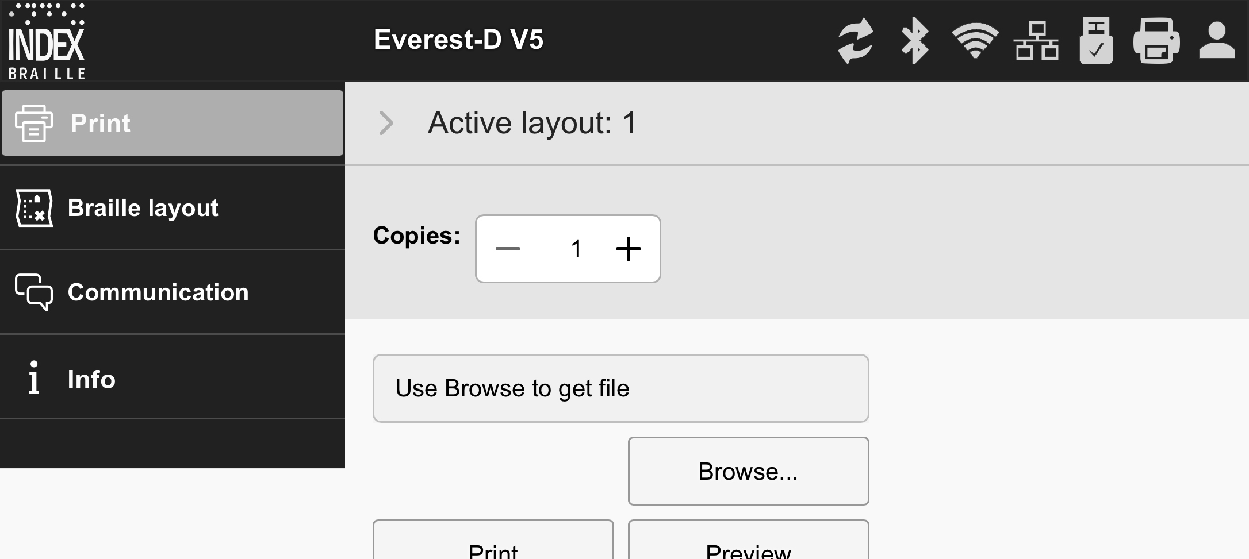

Function in BRAILLE LAYOUT
  - Set active layout
  - Edit layout
Starts a wizard where the steps in advanced wizard can be edited and saved.
  - Add layout.
A layout with next available number will be added. It will have the same parameters as the Active layout and be selected as the new Active layout.
  - Delete layout
The selected layout will be deleted, it is not possible to delete Active layout.
  - Backup and Restore Layouts
    - Local, the memory of the printer
    - USB, the USB memory connected to the V5 printer
    - Distributor defaults
  - User defined paper
    - Create new paper (not supported in BrailleBox)
    - Delete paper
  - User defined tables
Liblouis text-to-braille translation tables in .ctb .cti and .tbl are supported. This table may be selected in text-to-braille-translation in the layout.

Communication setup
The BrailleApp communication menu includes:
  - USB
    - Safely remove USB media
  - WiFi
    - WiFi on/off
      - Connected WiFi, SSID and IP address
      - Trusted WiFi Ap's range
      - WiFi in Ap's range
      - WiFi settings
        - Connect to hidden network
        - WiFi region settings
      - Hardware address of the printer, WiFi MAC address
  - Wired network
    - Set static or dynamic (DHCP) network port
    - When DHCP is selected, the IP parameters are presented (Subnet Mask, Gateway, Dynamic Name Server, Alternative Name Server)
    - When static IP is selected, define above parameters
    - Hardware address of the printer, wired network MAC address
    - Hostname: edit and save hostname for the printer
  - Bluetooth
    - Bluetooth on/off
    - Make printers discoverable
    - Paired Bluetooth devices

Monitor icons on BrailleApp
The monitor icon's is located on the top right side corner.
  - Firmware update; Green=up to date, Red=new firmware is available
    - Update from Internet
    - Update from USB memory
  - Bluetooth; blue = connected, flickering = trying to connect
    - on/off
    - paired devices
  - WiFi network; blue = connected, flickering = trying to connect
    - on/off
    - SSID and IP address
    - Disconnect, connect, etc
  - Wired network; blue = connected, flickering=trying to connect
    - Present IP address
  - USB memory stick; blue = USB memory stick is connected
    - Safely remove USB device
  - Printer status; idle = green, printing = yellow, red = error
  - Login access level, account setting and logout
As default login is disabled and the user have administrator access. Enable account settings by login/ account settings and select Enabled.
    - User green, default = userpassword
Access to print and info
    - Administrator blue; default = adminpassword
Access to print, braille layout, communication and info
    - Service red; default = service"serial number no spaces"
In addition also access to the PROTECTED SERVICE menu with command center and system details.
The service user should be used by authorized service technicians only.

Info page
Includes following information:
  - Printer model
  - Serial number
  - Firmware version
  - Printed pages
  - Hammer batch
  - Liblouis version
    - The "i" icon gives a link to Liblouis list of text-to-braille translation files in this Liblouis version.

Index-direct-Braille (idB)
idB supports:
  - Braille in grade 0 (computer), 1 (literary), and 2 (contracted) translated by Liblouis text-to-braille translation files.
By upgrading the firmware on V5 embosser, the Liblouis table are upgraded to latest revision.
  - Word (.doc) files
  - PDF (.pdf) files
  - Word .docx file
  - .epub file
  - Page numbering
  - Volume handling

Link to Liblouis web site

Link to Liblouis V3.12.0 list of tables
Link to information about Index-direct-Braille
Link to firmware upgrade instructions

Printing from USB Memory stick
  - An Index V5 printer.
  - A USB memory stick.
  - Standard text file (docx, doc, pdf, epub) using idB text-to-braille to translate and format following the Active Layout settings.
  - Braille files (.ipf .brl, .brf), already translated to braille is printed directly.

Steps for printing
  - Set up the Active Layout to your preferences.
  - Press the MENU key on the control panel. It is also possible print from USB memory using the BrailleApp.
  - Select Print / Print from USB memory stick.
  - Find the file by using the arrow keys. The speech feedback will guide you to navigate the USB file structure (English folder and file names).
  - Press OK to print the selected file.

Emboss with idB in Windows
  - Save and close the file in Word as .doc, .docx, .epub or PDF format.
  - Right click on the file from the list, and select Index-direct-Braille.
    - Select your printer model and click OK.
    - The file will now be transmitted to the selected Index printer.

Emboss with idB in Mac
  - Open the document in your preferred editor/viewer program (Preview OS X).
  - Go to file. Select Print and select an installed Index printer.
  - The file will now be transmitted to the selected Index printer.

Emboss with idB in Linux
  - Open the document in your preferred editor/viewer.
  - Go to the file. Select Print and select an installed Index printer. Press OK.
  - The file will now be transmitted to the selected Index printer.

External braille editor
Emboss with a commercial or freeware braille editor
The majority of braille editors available are compatible with Index Braille printers. For more information on compatible braille editors, please check below link:
Link to more information about Braille editors

Control panel
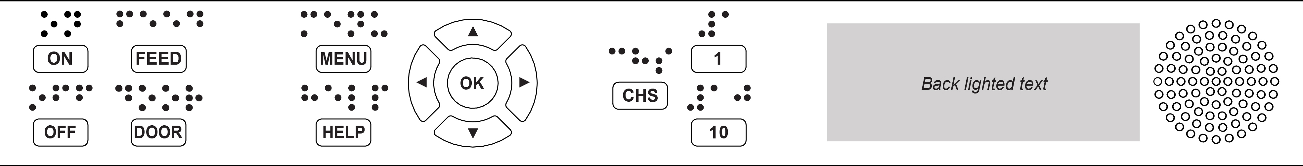

Menu summary

V5 menu

- About MENU mode:
  - When a function is completed, the printer goes into idle mode.
  - After 2 minutes on MENU mode, without any keystrokes, the printer will cancel changes automatically without saving and then go into idle mode.

Key functions
TYPES | KEYS | FUNCTIONS
GENERAL KEYS | ON | Power on.  Online mode.  Cancel MENU function without saving.
 | OFF | Pause embossing.  Power off (hold OFF for 5 seconds).
 | FEED | Feed paper.  Eject paper.
 | DOOR | Open or close braille tray. BrailleBox only.
 | HELP | Speech feedback help information.  Lighted when important information is available.  Hold HELP for 15 seconds to start remote support.
MENU KEYS | MENU | Open MENU mode.
 | ARROW UP | Move to previous MENU item.  In idle mode, go to preferred layout, press OK to make it the active layout
 | ARROW DOWN | Move to next MENU item.
 | ARROW LEFT | Move to a higher MENU level.
 | ARROW RIGHT | Move to lower MENU level.  Move to next step in wizard.
 | OK | Select, save, open, close and start.  Confirm action with OK.
NUMBER KEYS | 1 | Normally "1" represents the value 1.
 | 10 | Normally "10" represent value 10.  Run paper arm release sequence. BrailleBox only.
 | CHS | Toggle between increase and decrease.  Restart the printer. Hold CHS for 10 seconds.

DOUBLE KEYS | OFF + FEED | Stop embossing.
 | FEED + FEED | Place paper in emboss position. Basic and FanFold.
 | FEED + OFF | Reverse the paper out of the printer. Basic and FanFold.
 | HELP + HELP | Prints help information in letter graphics and braille.
 | HELP + CHS | Toggle between local and English speech feedback.
 | Hold HELP + CHS | Pre-release channel: Press down HELP, at the same time press the CHS key.
 | HELP + MENU | Provide speech feedback in Active braille page layout. (characters per line and lines per page)
 | HELP + ON | Print hammer test page.
 | Hold HELP + ON | Start firmware upgrade from Internet
 | Hold HELP + OFF | Start firmware upgrade from USB memory stick
 | HELP + OFF | Safely remove USB memory stick.
 | HELP + FEED | Light-up text indicates process sensors toggle between on and off.
 | Hold HELP + 1 | WiFi-Enabled/disabled
 | HELP + 10 | Provide speech feedback on available wired and/or Wi-Fi IP address.
 | Hold HELP + 10 | WiFi-disabled
 | HELP +  ARROW RIGHT | Start Wireless Protected Setup (WPS push button).
 | HELP +  ARROW DOWN | Start 'Insert transport locking wizard'. Follow the wizard instructions. After completed, the printer will restart.
 | FEED + ARROW RIGHT | Only FanFold in paper out/jam stage. Move the paper out of the printer.
 | FEED + ARROW DOWN | Power off paper feed motors, so the paper can be moved manually.
When it represents another value, it is presented by speech feedback.

Multiple layouts to customize
Index V5 printers are installed with 1-9 user-defined layouts.
Active layout
The Active Layout is the current one in use. All changes to the layout settings are made in the active layout. The layout includes paper size, braille page setup, page number position, idB text-to-braille translation and grade etc.
Select active layout
  - With arrow keys. When the printer is in idle mode, press arrow up/down to go to the preferred layout. Then press OK to select it as the active layout. This is the same function as in Index V4 printers.
  - With MENU function. Go to MENU / Braille layout / Select active layout / The Layouts are presented with "layout number, paper size and print format"
  - With the BrailleApp. Go to BRAILLE LAYOUT, go to prefered layout and press the set-active-layout key. In the BrailleApp the complete list of parameters is presented.

Menu option V5

MAIN MENU | SUB MENU | FUNCTION | INFORMATION
Print | Print previous document | Print complete document. | Number of copies.
 |  | Print part of document. | Page range.
 | Print from USB memory | Select a folder or document with arrow keys up / down / right=in / left=out, and press OK to print. | Use idB printing following settings in Active Layout.
 | Print demo files | Select a file and print. | The file name describes each document.
 | Print braille manual | Select a language from the list. | Use Active Layout
 | Print test document | Print, information page | print test document, print information page
 |  | Print, hammer test | Print test document, print hammer test
 |  | Print, braille layout | Print test document, print braille layout + press OK to start.
 |  | Print, network information | Print test document, print network information
 |  | Print, folding line test
 |  | Print, internal parameter value list
 |  | Print, step length for embossing head test
 |  | Print, delay time for solenoid test
 |  | Print, gap between print head test | Only BrailleBox
 |  | Print, print head reference position test | BrailleBox, FanFold
 |  | Print, distance from sensor to paper edge test
Braille layout | Edit active  layout 1-9 | Standard layout wizard
 |  | Advanced wizard.
 | User-defined paper | Wizard to create user defined paper | BrailleBox has fix paper sizes
 |  | Delete user-defined paper. | .
 | Add layout | Add layout. The new layout is selected and has the same setting as the previous active layout. | The new layout gets the lowest available layout number.
 | Delete layout | Delete a specific layout. | It is not possible to delete Active Layout.
 | Backup layouts | Back up current layouts to USB memory.
 |  | Back up current layouts to internal memory.
 | Restore layouts | Restore layouts from USB memory.
 |  | Restore layouts from internal system memory.
 |  | Restore default distributor layouts.
 |  | Restore default factory layouts.
 | Select active layout | Select the active layout. | Maximum 9 layouts.
Communica-  tion | USB | Safely remove the USB memory stick.
 | Manage Wi-Fi network | Set WiFi power on/off | Link to set up Wi-Fi network from control panel.
 |  | Current Wi-Fi network/ Disconnect, Forget
 |  | List known networks/ Disconnect, Forget
 |  | List Wi-Fi networks supporting WPS.
 |  | List all Wi-Fi networks/ Connect
 | Wizard for wired network | DHCP/Static IP: IP address, Netmask, Gateway, Dynamic Name Server.
 | Manage Bluetooth | Set Bluetooth power
 |  | Make Bluetooth discoverable
 |  | Forget device
 | Speech feedback | Select volume. | Low/medium/high.
 |  | Select language. | Select from the list.

MAIN MENU | SUB MENU | FUNCTION | INFORMATION
User service | Firmware update | Firmware upgrade from internet.
 |  | Firmware upgrade from USB memory stick.
 | Printing speed | Printing speed | Low/ Medium/ High/ Draft
 | Wait before printing next document | on/off. When ON, press OK to printing next document
 | Light feedback for text on control panel | on/off:
 | Paper out offset | Hood with knife/ Floor standing hood/ paper remain in print head | Only Basic-D
 | Adjust cut of position, hood with knife | Fine adjustment for hood with knife | Only Basic-D
 | Set paper jam sensor | on/off | Basic-D and FanFold
 | Adjustable line spacing | yes/no; Adjust line spacing with +/- 2.0 millimeters | Basic-D and Everest-D
 | Paper step length calibration | Everest  BrailleBox  FanFold | Links to FAQ  FAQ Everest  FAQ BrailleBox  FAQ FanFold
 | Distance from paper sensor to paper edge | Distance in millimeters
 | Reference position of print heads | BrailleBox and FanFold only | BrailleBox, FanFold, Link, FAQ
 | Calibration of braille tray door |  | BrailleBox only
 | Backup settings | Back up settings to USB memory.
 |  | Back up settings to internal memory.
 | Restore settings | Restore settings from USB memory.
 |  | Restore settings from internal memory.
 | Insert transport locking | Places the embossing head in transport position, power off.

MENU | SUB MENU | FUNCTION | INFO
Protected service (password protected) | Step length on embossing head | 8 pages with alternative step lengths are printed. 0 is the default value. Select best option.
 | Delay time for solenoids | 8 pages with alternative delay time for solenoids are printed. 0 is the default value. Select best option.
 | Gap between print heads |  | BrailleBox only
 | Command center | Start command center. | Internal factory functions
 | Production test | Wizard for production test
 | Print production test | Print a defined number of pages suitable for testing a printer after service
 | Select embosser model | This function select which embosser model the high level CPU are installed. Same board for BB/FF and Basic/Everest/Juliet and Romeo.

Wizards
Wizards are used to guide users through setup, calibration, adjustment etc. All wizards follow the same user interface structure and the speech feedback will provide further instructions.
- Start a wizard in the MENU structure
- Follow the wizard by pressing the right arrow to next step and left arrow to previous step.
- When edit a value, press:
OK to edit, Arrow up/down to select and OK again to save.
- Wizards are completed when pressing OK in the far right step
"Wizard completed. Press OK to save".

Standard layout wizard

STANDARD WIZARD |  | GUIDELINES | ADDITIONAL INFORMATION
Paper size |  | Select paper size available in the region used in the printer | Asian, European, US, Russian, or Japanese
 |  | If paper from other regions are needed, select advanced layout and select this region. | User defined paper size may be defined in Basic-D and Everest-D only.
Print type |  | Select from list. | Basic-D: Double/single, Z-folded double/single, and Z-folded sideways single/double-sided.  Everest-D and BrailleBox: Double/single, and booklet double/single-sided.
Folding line |  | Select from list. | Available when booklet print type is selected.
6 or 8 dots braille cell |  | Select from list | 6 or 8 dot setting here will present only if the Liblouis table support 6 or 8 dots.
Text-to-braille translation table |  | Select language, grade, and version. | Liblouis text-to-braille translation, G0 = computer braille, G1 = literary braille, G2 = contracted braille. Arrow up/down = 1 step, 1/10 = to next character in the alphabet
Legacy braille translation table |  | This ASCII to braille table is used when an ASCII sting .txt is transferred to the V5 printer directly without idB or the BrailleApp | Link to Legacy braille tables in V5 printer.
Lines per page |  | Edit with 1/10/CHS.
Top margin |  | Select from list. | Available when margin space is available.
Braille page number |  | Select from list with position on the page. | Available when top and/or bottom margins are available.
Characters per line |  | Edit with 1/10/CHS.
Binding margin |  | Select from list. | Available when binding margin space is available.  In booklet format the minimum binding margin is 1 character.
Wizard completed |  | Press OK to save.

Advanced layout wizard
The additional items in advanced wizard are marked with larger bold text.

ADVANCED WIZARD |  | GUIDELINES | ADDITIONAL INFORMATION
Paper region |  | Europe, United States, Russia, Japan, South East Asia, World (all paper sizes) | User-defined paper is presented in all regions.
Paper size |  | Select from list.
First line offset |  | Distance from paper edge to first braille cell i millimeter
Print type |  | Select from list. | Basic-D: Double/single, Z-folded double/single, and Z-folded sideways single/double-sided.  Everest-D and BrailleBox: Double/single, and booklet double/single-sided.
Folding line |  | Select from list. | Available when booklet print type is selected.
Line spacing |  | Select from list. | Currently support single or double line spacing.
Adjust line spacing |  | Adjustable line spacing | +/- 2,5 mm
Braille cell size |  | Select from list standard 2,5, Japanese 2.2, or Jumbo 3.2 mm | Supported in Basic-D and Everest-D.
6 or 8 dots braille cell |  | Select from list.
Text-to-Braille translation table |  | Used by idB when Word/pdf/txt document is printed. Select language, grade, and version. | G0=computer braille, G1=literary braille, G2=contracted braille.
Legacy Braille translation table |  | Used by braille editors and IbPrint | List of braille tables for Index V5.
Lines per page |  | Edit with 1/10/CHS.
Top margin |  | Select from list. | Available when margin space is available.
Braille page number |  | Select from list with position on the page.
Characters per line |  | Edit with 1/10/CHS.
Binding margin |  | Select from list. | Available when binding margin space is available.  In booklet format the minimum binding margin is 1 character.
Volume separation |  | Number of pages in each braille volume, select from list. | Divide a document into volumes.  Each booklet holds maximum of 80 pages per volume.
Braille volume number |  | Add "V1" (Volume 1) on the left side of the braille page number. | Enabled when:  - Braille page number is ON.  - Volume handling is ON.
Multiple impacts |  | Select 1 to 5 impacts one each braille dot | More than one impact is required when printing on labels or other thicker materials.
Wizard completed |  | Wizard completed. Press OK to save.

User defined paper wizard
User defined paper sizes are supported in Basic-D, Everest-D and FanFold.

User defined paper | Go to Menu/ Braille layout/ User defined paper/ Wizard to create user defined paper. | Arrow right or left for moving in the wizard. Press OK to open for editing a value
Next empty paper number 1-9 | User defined paper no # (1-9), paper size units | Move between wizard steps with arrow right (next step) or arrow left (previous step)
Paper size units | Select mm or inch (Basic-D, FanFold-D only inch) | Press arrow right to next step
Paper width | Edit paper width | Edit;  arrow up/arrow down = 50 mm or 1 inch,  10 = 10 mm or 1/2 inch,  1 = 1 mm or partial inch.  CHS= change to plus or minus
Paper length | Edit paper length
Complete wizard | Press OK to save your user defined paper

User service wizards

Adjust paper out offset wizard

Wizard steps | Menu/ user service// Paper out settings/ Wizard to adjust cut off position | For Basic-D when used with Index Acoustic hood with cutting mechanism
Load fresh paper | Load fresh paper and press OK to continue
Move to cut off position, cut the paper | Cut the paper, press OK to continue | The printer moves the paper into cut-off position  Cut-off the paper with the cutting mechanism
Measure and Adjust | Measure the deviation between cutting position and paper perforation, press OK to adjust. | Arrow up to increase 0,1 mm  Arrow down to decrease 0,1 mm
End of wizard | Press OK to save

Paper step-length calibration, FanFold
This function calibrates the paper movement made by 4 pair of soft rollers to fit the movement of the paper tractors.

Menu position | Menu/ user service/ Paper step-length calibration
Preparation 3 sheets | Separate the paper into three contiguous paper sheets. | Make sure that the the same paper size is selected in active layout as the calibration paper
Paper in tractors | Put the three contiguous paper sheets in the tractors and press OK to load.
Paper on top of the tractors | Open the lids on both tractors. Remove the paper and close the lids again. Put the paper above the tractors. Press OK to calibrate.
Unload paper | Press OK to unload paper
Complete | Wizard completed, press OK to save.

Paper step-lengt calibration, EV/BB

Menu position | Menu/ user service/ Paper step-length calibration
Insert paper | Insert paper into the sheet-feeder | Make sure that the the same paper size is selected in active layout as the calibration paper
Confirm paper size | Press OK to confirm correct paper size and start calibration
Measure one paper | One paper sheet is now moved through the printer and the step-length
 | Print, Braille Layout | (A page with current layout will be printed)
 | Press OK to close door | BrailleBox only
Complete | Wizard completed, press OK to save or ON to cancel

Distance from sensor to paper edge
For Everest-D and BrailleBox
Start wizard | Menu/ user service/ Braille adjustments/ Wizard for distance from sensor to paper edge
Print, distance from sensor to paper edge test | Prints a pattern with dots where the line of single dot should be on the paper edge
Edit "set distance from paper sensor to paper edge" | Press OK to open for edit, 1/10 to adjust and OK to save | 1=0,1 mm and 10=1 mm.  Increased value moves the braille block into the paper.
Print "folding line test page" | Check folding line position. If OK press arrow right
End of wizard | Press OK to save

