Replacement of drawer "Rear stop lever"

- Remove the paper drawer.
- Remove the older rear stop lever by pulling on the piece indicated by the yellow arrow seen in picture 1 below.
- Press the new rear stop lever in place.
- Place the paper drawer back in the Braille Box.

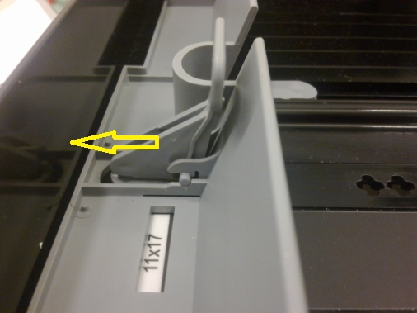
Picture 1

