Service document – Replacing solenoid driver
Date: 2019-11-12
Part 1 is for:
- Basic-D V4, Main electronic board, PCB 1360A
- Everest-D V4, Main electronic board, PCB 1360A
- Basic-D V5, Main electronic board, PCB 1365A
- Everest-D V5, Main electronic board, PCB 1365A
Part 2 is for:
- BrailleBox V4, Driver electronic board, PCB 1362B
- BrailleBox V5, Driver electronic board, PCB 1365B

Skill level and soldering
- For personal with service knowledge of Index Braille printers.
- Soldering of PCB components must be done with personal with soldering experience.
- Use soldering equipment that can handle surface montage components.
Preparing
Identify witch solenoid number (1 to 13) that is not working by printing a “hammer test page”. Print it by pressing HELP followed by ON or from the control panel:
MENU/Print/ Print Test document/ Print hammer test/ OK
(picture)
On the “hammer test page” it is easy to find the faulty solenoid driver.
Dismount the main electronic board on Basic/Everest or the driver electronic board on BrailleBox/FanFold.

Material – Components to be replaced
For each solenoid driver normally two components must be replaced.
Resistor, marking R<number>. Type: 0.1R, Size 1218, 1W, Mfr: Yageo No: RL1218FK-070R1L
Transistor, marking TH<number>. Type: N-MOSFET, Size D-PAK, 150V, 24A, Mfr:IR/Infineon No: IRFR24N15D
Components can be bought from catalog distributors worldwide. Local distributor can also be used, for that you need to investigate locally.
Example catalog distributors.
Mouser: https://www.mouser.com/ProductDetail/Yageo/RL1218FK-070R1L?qs=%2Fha2pyFaduhMXcbYXT%252BqUt9bzQwE2JLu%2F0UthSZN1V%252BczcVoPX8PnA%3D%3D
Farnell: https://se.farnell.com/yageo/rl1218fk-070r1l/motst-tjockfilm-0r1-1-1w-1218/dp/1377031
Mouser: https://www.mouser.com/ProductDetail/Infineon-Technologies/IRFR24N15DTRPBF?qs=%2Fha2pyFadugXD2Yv9aY2YXAhvEoQhaJGG%252BIvDQeyXGZh3OnR%2FqOV0w%3D%3D
Digikey: https://www.digikey.com/product-detail/en/infineon-technologies/IRFR24N15DTRPBF/IRFR24N15DTRPBFCT-ND/2441041

Component location on electronic board
The positions of the driver resistor/transistor are the same for Basic-D and Everest-D V4 and V5, see below picture. The yellow marking shows transistor and corresponding resistor for each solenoid marked with solenoid number.

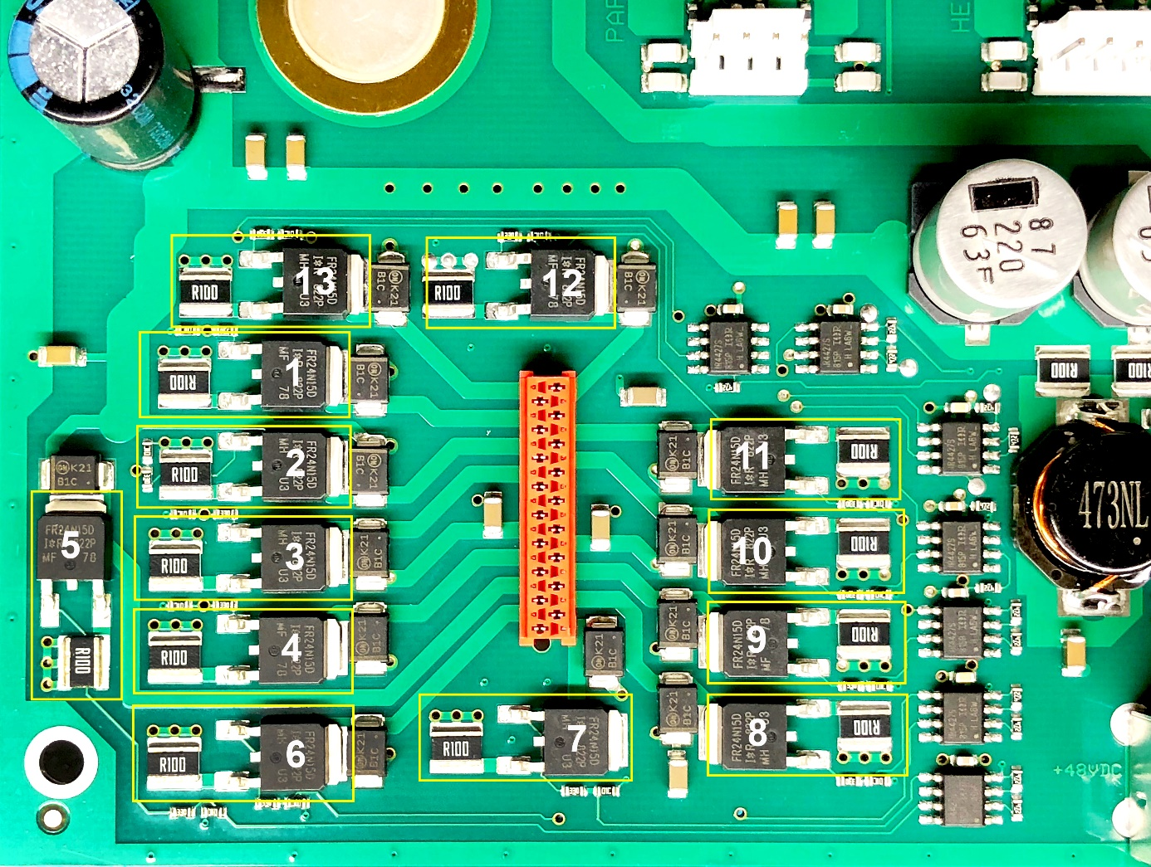

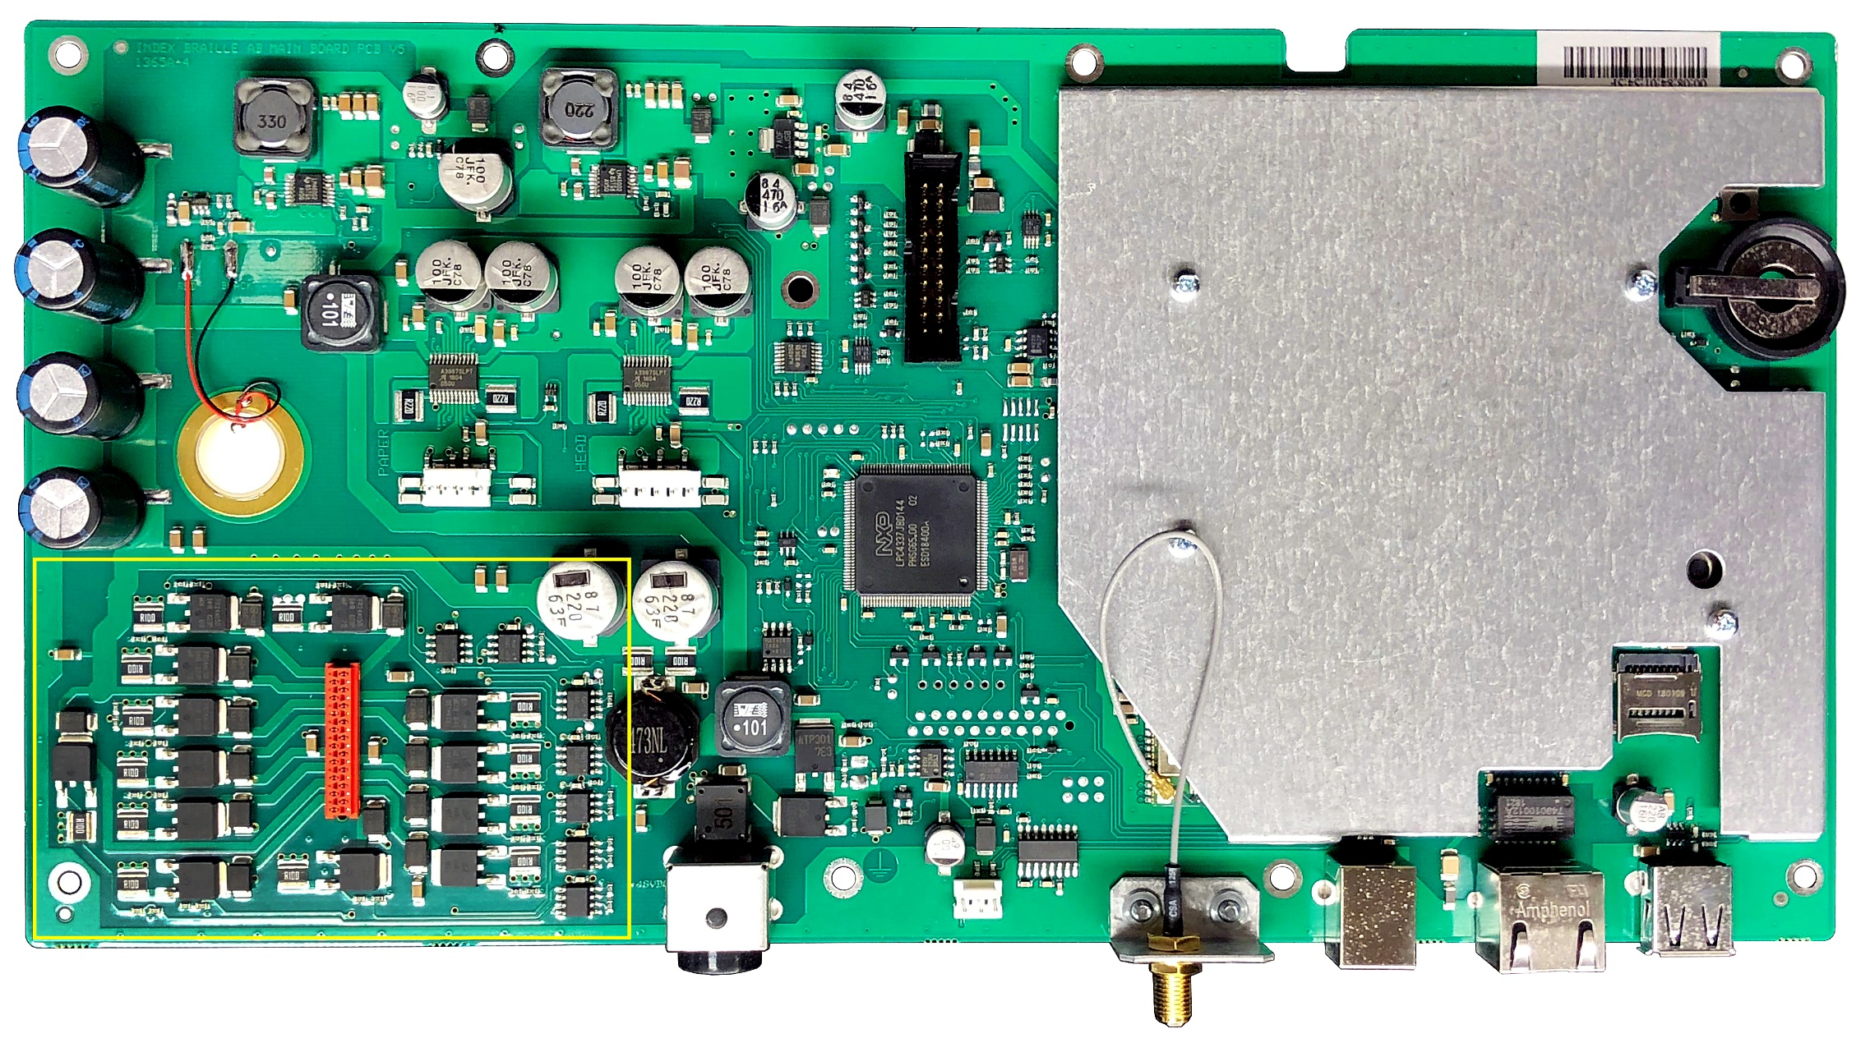
Component location on BrailleBox/FanFold-D driver electronic boards
For BrailleBox V4 and V5 and FanFold-D V5 the position of the resistors and transistors are on the same place, see below pictures.
The yellow marking shows transistor and resistor for each solenoid marked with solenoid number.

